**Task 1: Creating a Data Frame and Plotting a Normal Distribution**

**Using R, create a data frame with two vectors.**

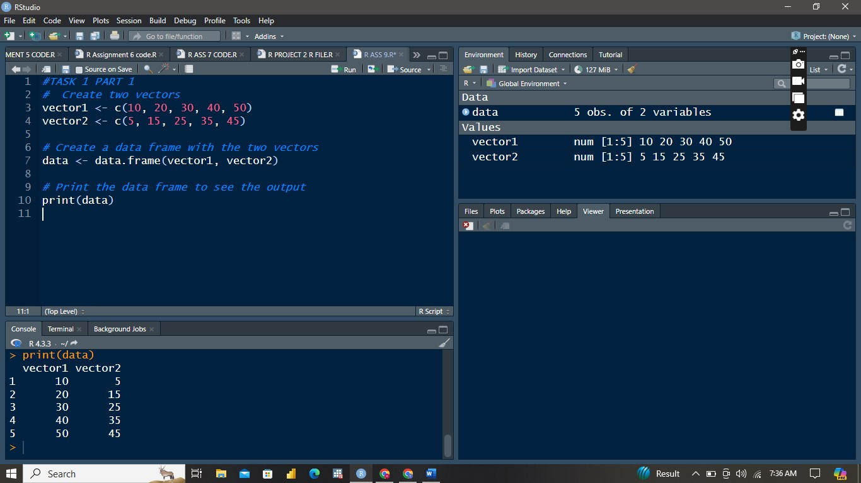

**Plot a normal distribution based on one of the vectors.**

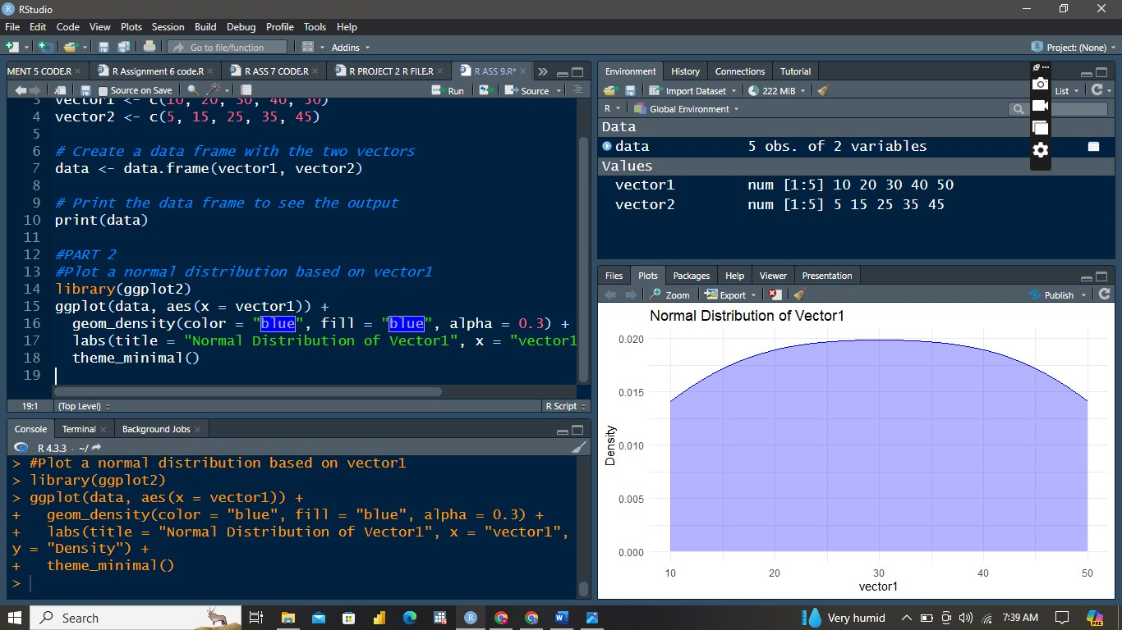

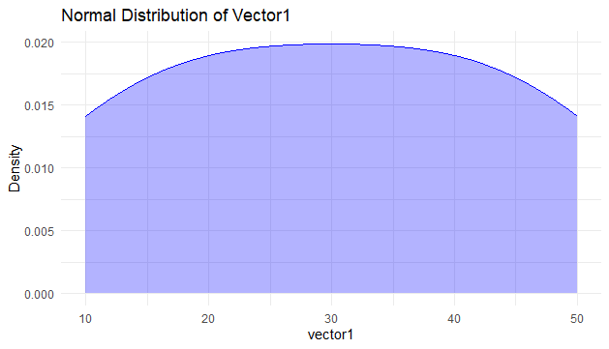

**EXPLANATION**

The plot illustrates the density distribution of `vector1`. It shows a near-uniform distribution across its range (10 to 50), with density values remaining relatively flat around 0.02. This indicates that `vector1` does not follow a typical normal distribution**.**

**Task 2: Scatter Plot with Regression Line**

**Utilize the inbuilt airquality dataset in R.Plot a scatter plot with**

**a regression line.**

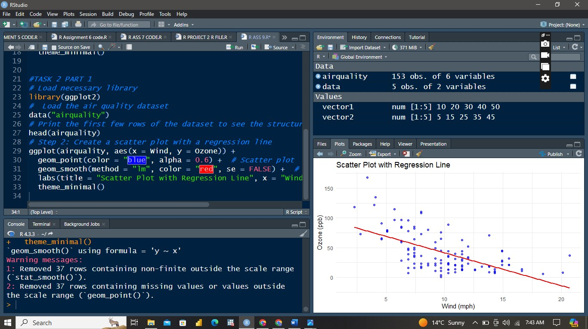

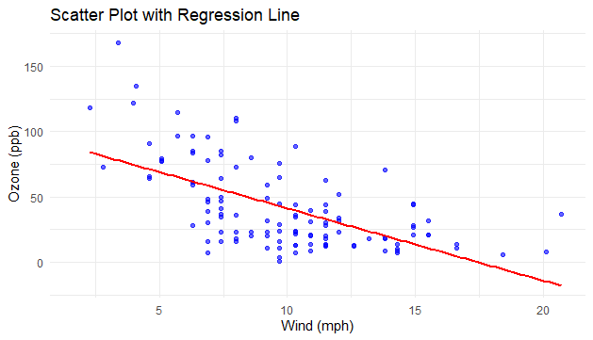

**Interpret the results of the scatter plot and regression analysis.**

The scatter plot illustrates the relationship between wind speed (in mph) and ozone levels (in ppb) from the `air quality` dataset. Each blue point represents an observation. The red regression line, added using a linear model, indicates a negative correlation between wind speed and ozone levels. As wind speed increases, ozone levels tend to decrease. This downward trend suggests that higher wind speeds are associated with lower concentrations of ozone in the air. The plot visually reinforces the inverse relationship between the two variables, with the regression line summarizing the overall trend in the data.

**Task 3: Box Plot of the Solar Variable**

**Using the same air quality dataset, plot a box plot for the**

**"Solar.R" variable.**

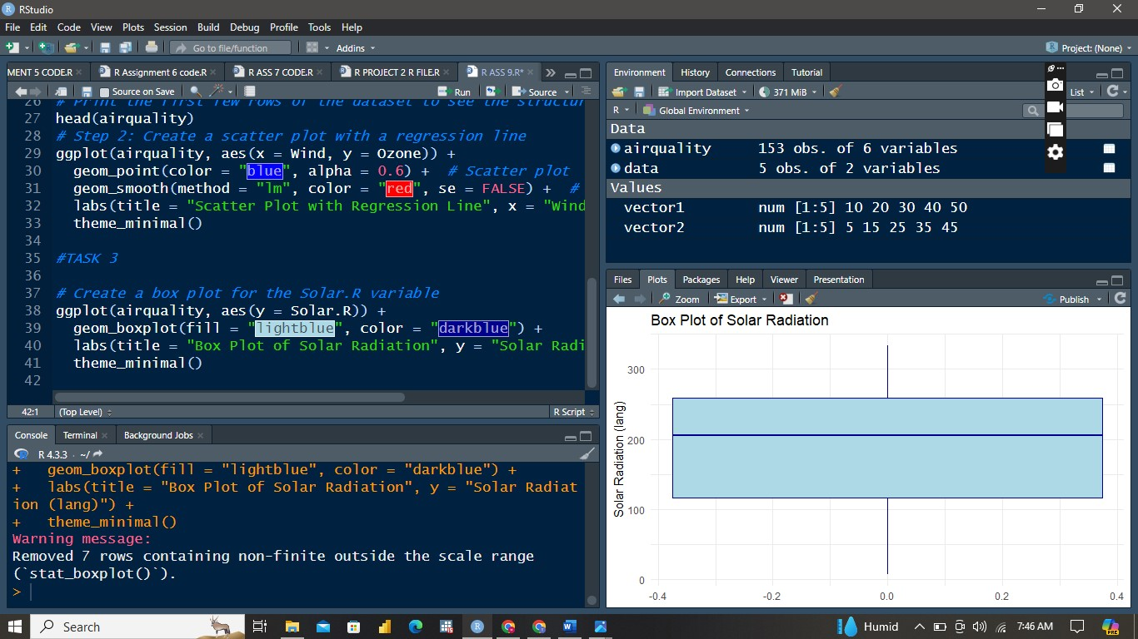

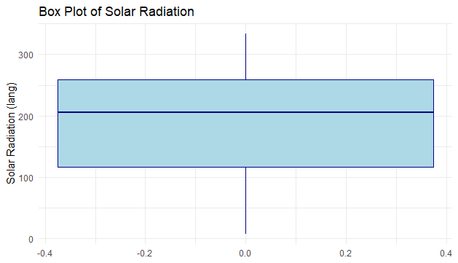

**Interpret the box plot.**

The box plot of the `Solar.R` variable from the `airquality` dataset shows that the median solar radiation is around 200 lang. The interquartile range (IQR), represented by the box, spans from approximately 100 to 300 lang, indicating where the middle 50% of the data lies. The whiskers extend to around 0 and just above 300 lang, covering the range of typical data values. A warning message indicates that non-finite values were removed. This plot provides a concise summary of the central tendency, variability, and spread of solar radiation values in the dataset.